Application Deployment
(Deploy the given React application to a production ready state)

Application:
Clone the below mentioned repository and deploy the application (Run application in port 3000).
Repo URL : https://github.com/Vennilavan12/Trend.git

Docker:
- Dockerize the application by creating Dockerfile
- Build an application and check output using docker image.

Terraform:
- Define infrastructure in main.tf to create VPC, IAM, EC2 with Jenkins, etc.
- Use terraform command to provision infrastructure.
DockerHub:
- Create a DockerHub repository.
Kubernetes:
- Setup Kubernetes in AWS EKS and Confirm EKS cluster is running.
- Write deployment and service YAML files.
- Deploy using kubectl via Jenkins.
Version Control:
- Push the codebase to a Git provider (GitHub).
- Add gitignore and dockerignore files and use CLI commands to push code.
Jenkins:
- Install Jenkins and necessary plugins (Docker, Git, Kubernetes, Pipeline) for build, push &deploy applications.
- Setup Github and jenkins integration using github webhook build trigger for auto build for every commit.
- Create a declarative pipeline script and pipeline project to build, push & deploy using CI-CD.
Monitoring:
- Setup a monitoring system to check the health of the cluster or application (opensource) is highly appreciable.
Submission Guidelines:
- GitHub Link: Submit full code repository.
- README File: Include setup instructions, pipeline explanation, and screenshots or create a document and attach all screenshots.
- Application deployed kubernetes Loadbalancer ARN.

====================OUTPUT======================================

Project Deployment Workflow:-
=========================

1. Infrastructure Setup (Terraform)
Terraform is used to create all the AWS resources needed for this project:
- VPC (network for all services)
- IAM roles and permissions
- EC2 instance for Jenkins
- EKS Kubernetes cluster
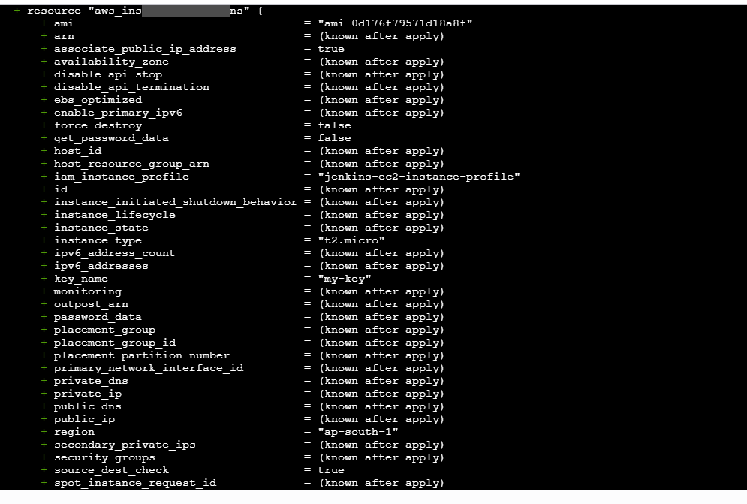
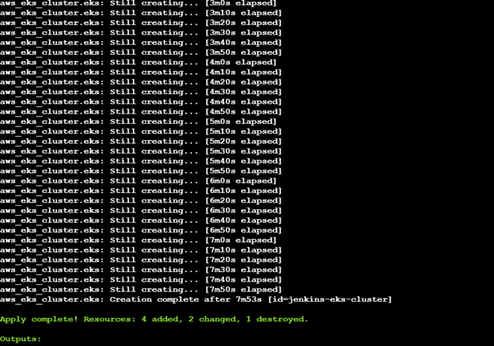
JENKINS SERVER:
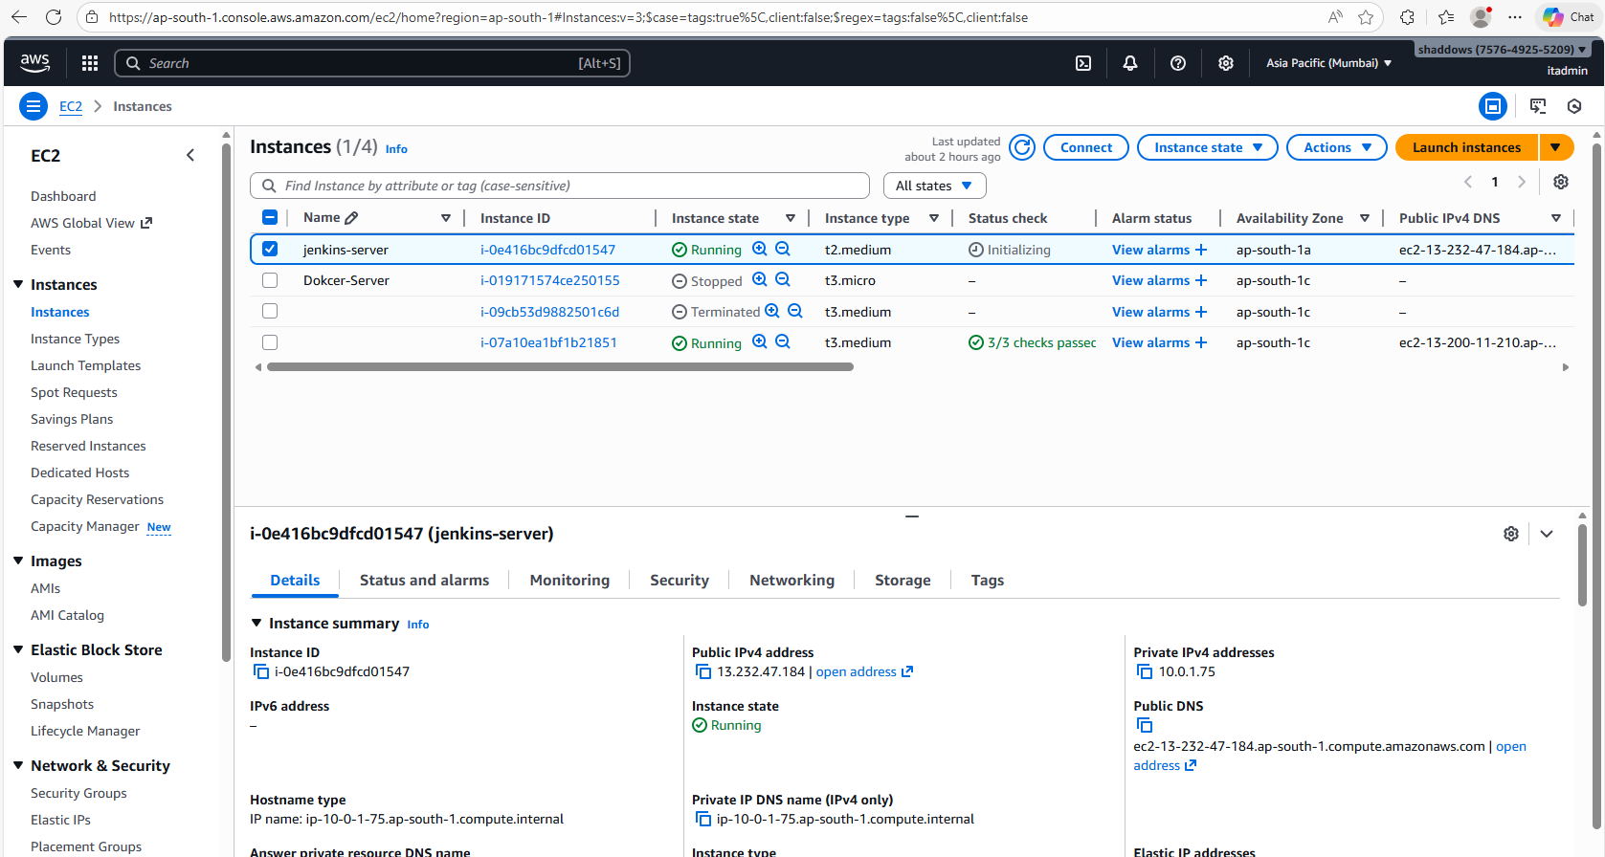
Jenkins URL:
- http://13.232.47.184:8080
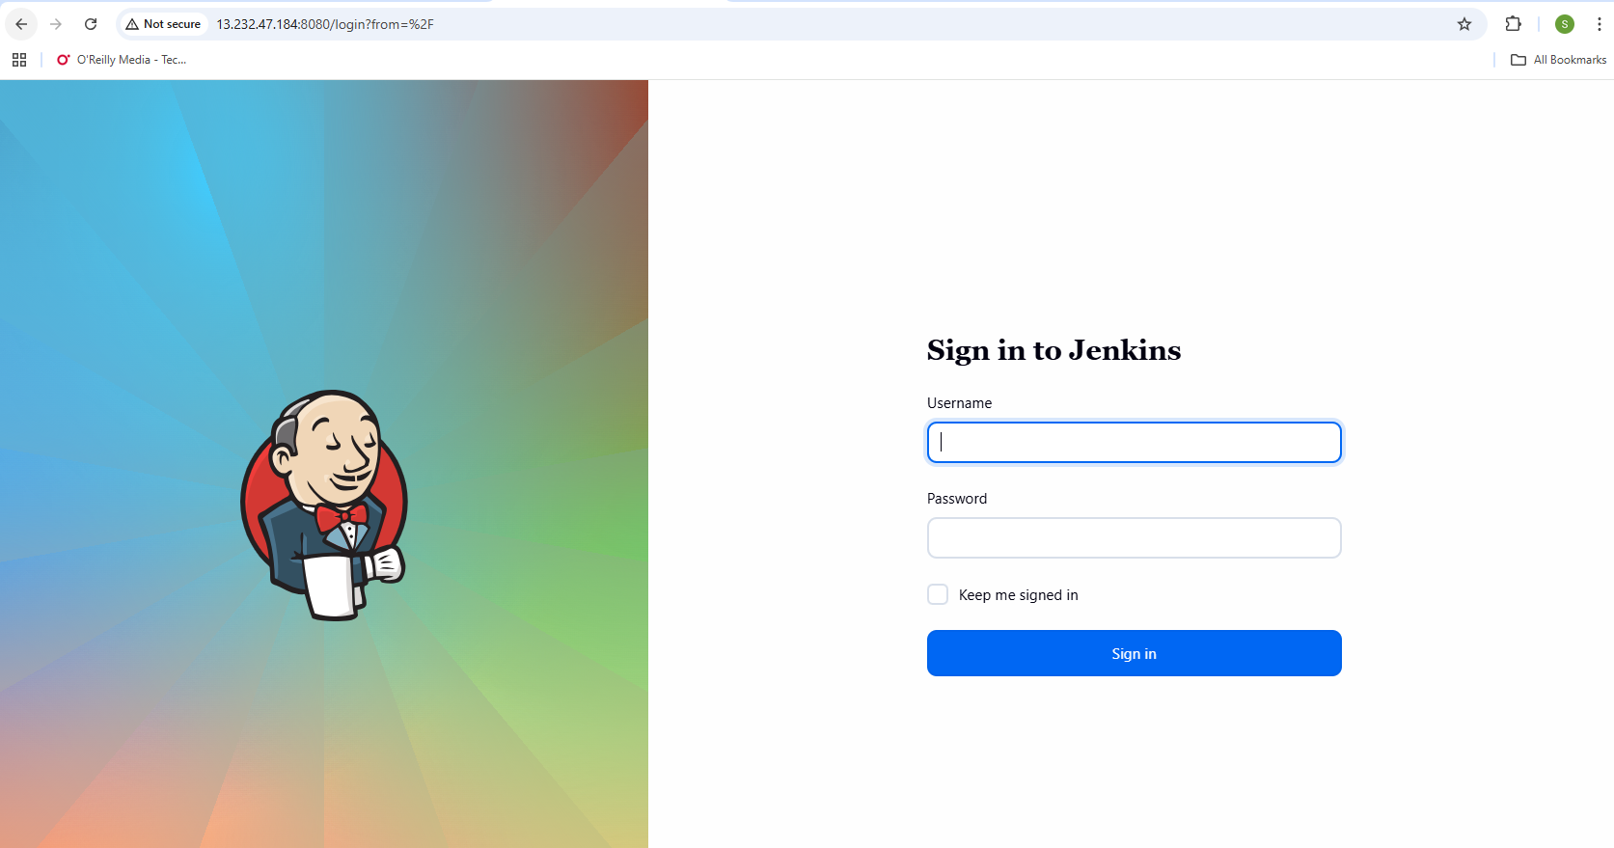
AWS EKS:
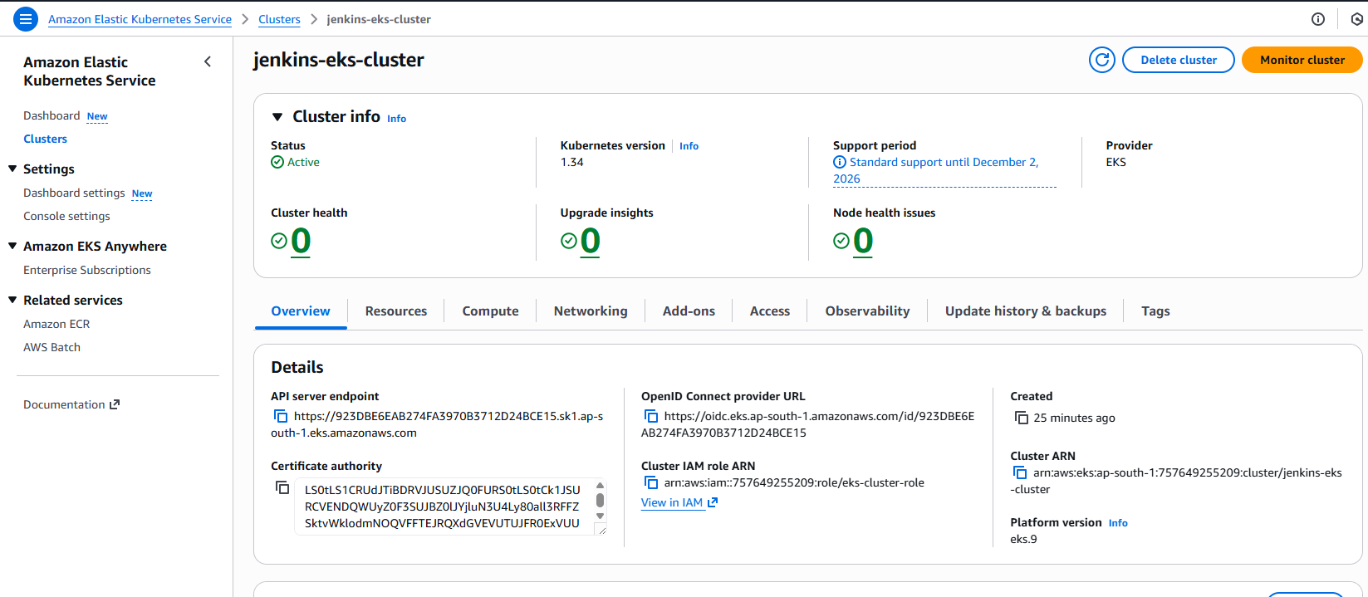
Terraform automatically provisions the entire environment so everything is ready for deployment.
2.Pushes Code to GitHub
Developers write code and push their changes to the GitHub repository.
This is the starting point of the CI/CD process
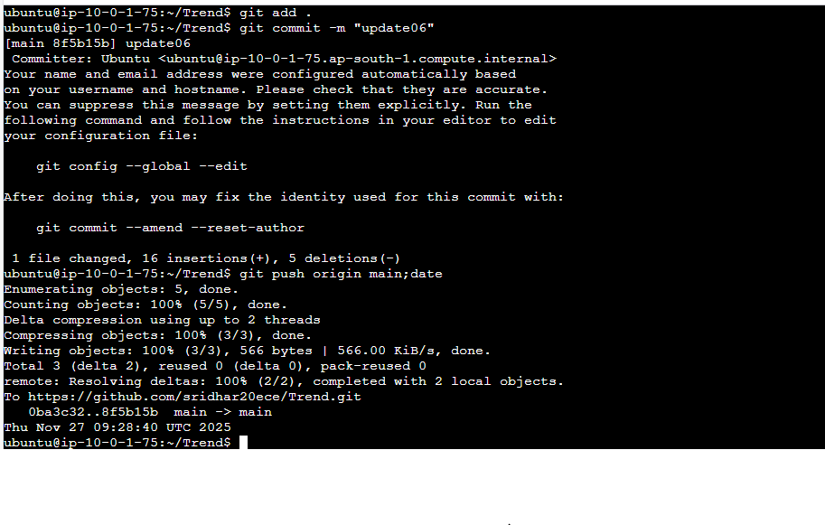
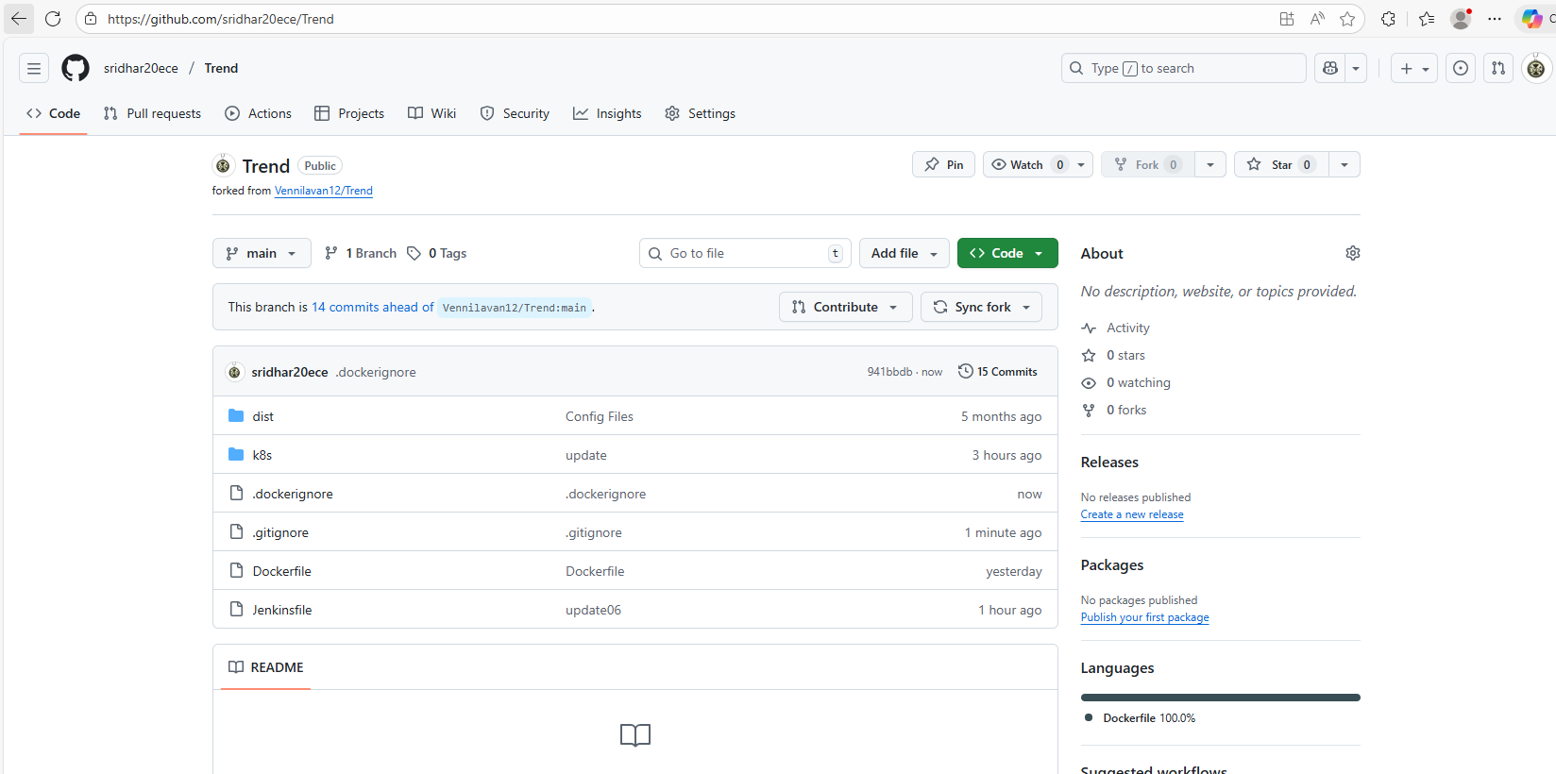
3. GitHub Webhook Triggers Jenkins
A GitHub webhook is configured to notify Jenkins every time a commit or push happens.
- Jenkins receives the webhook
- Jenkins automatically starts the pipeline
This gives a fully automated build and deployment system.
4. Jenkins Builds and Pushes Docker Image
Inside the Jenkins pipeline:
- Jenkins pulls the latest code
- Builds a Docker image
- Tags it with the commit ID and “latest”
- Pushes the image to DockerHub
This ensures every version is stored and can be re-deployed anytime.
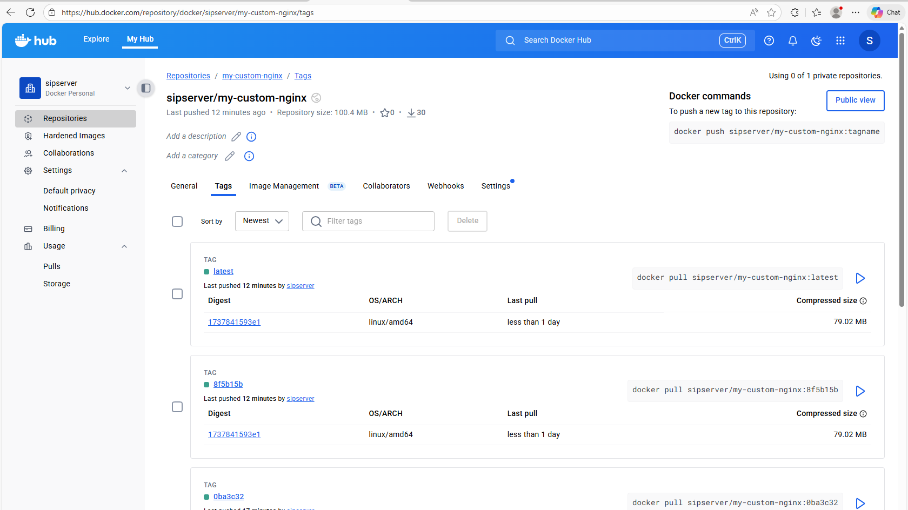
5. Jenkins Deploys to AWS EKS
After the Docker image is ready:
- Jenkins connects to the EKS cluster using kubectl
- Updates the deployment.yaml with the new image
- Applies deployment and service files
- Kubernetes creates or updates the pods running the application
This gives automated deployment into the Kubernetes cluster.
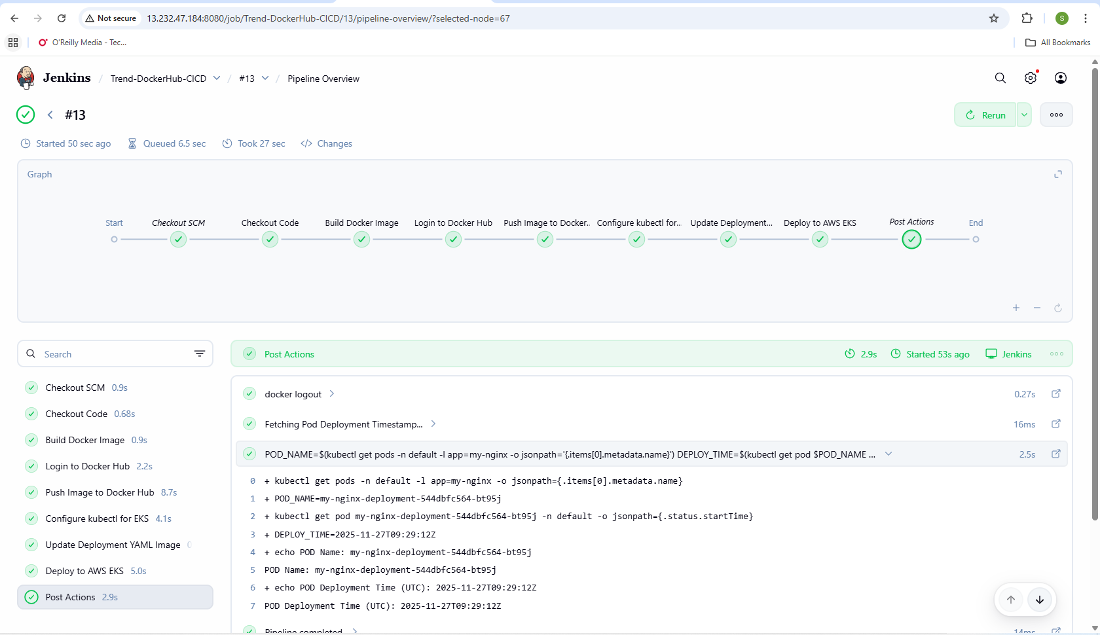
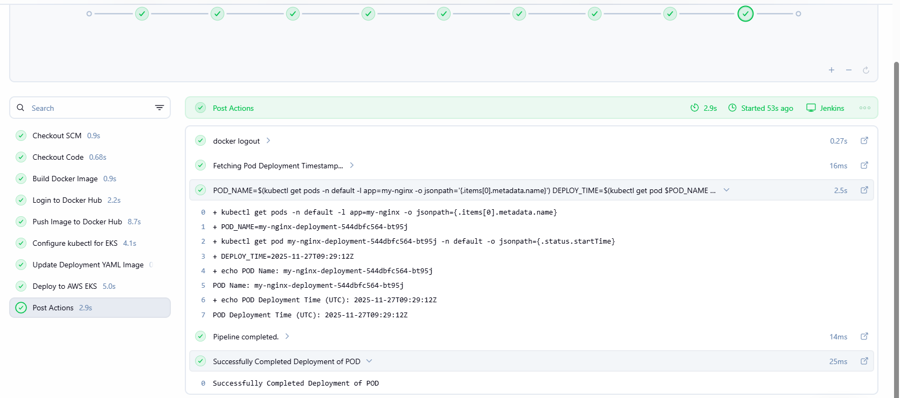
AWS EKS POD details:
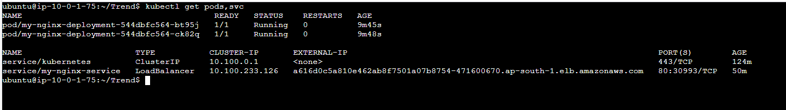
LoadBalancer URL:
http://a616d0c5a810e462ab8f7501a07b8754-471600670.ap-south-1.elb.amazonaws.com/

6. Monitoring the Application & Cluster
Monitoring tools like Prometheus and Grafana are used to check:
- EKS cluster health
- Node health
- Pod status
- CPU, memory, and network usage

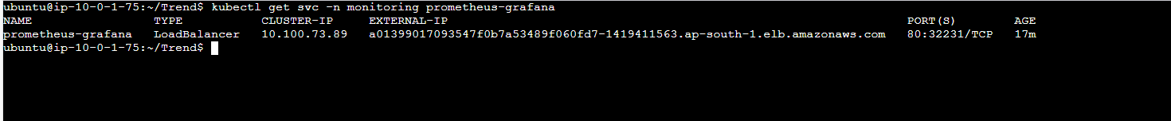
Prometheus, Grafana Login :

http://a01399017093547f0b7a53489f060fd7-1419411563.ap-south-1.elb.amazonaws.com/login
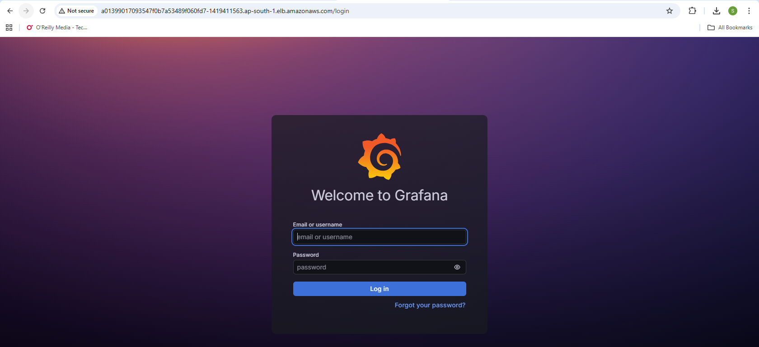
Monitoring POD health details :
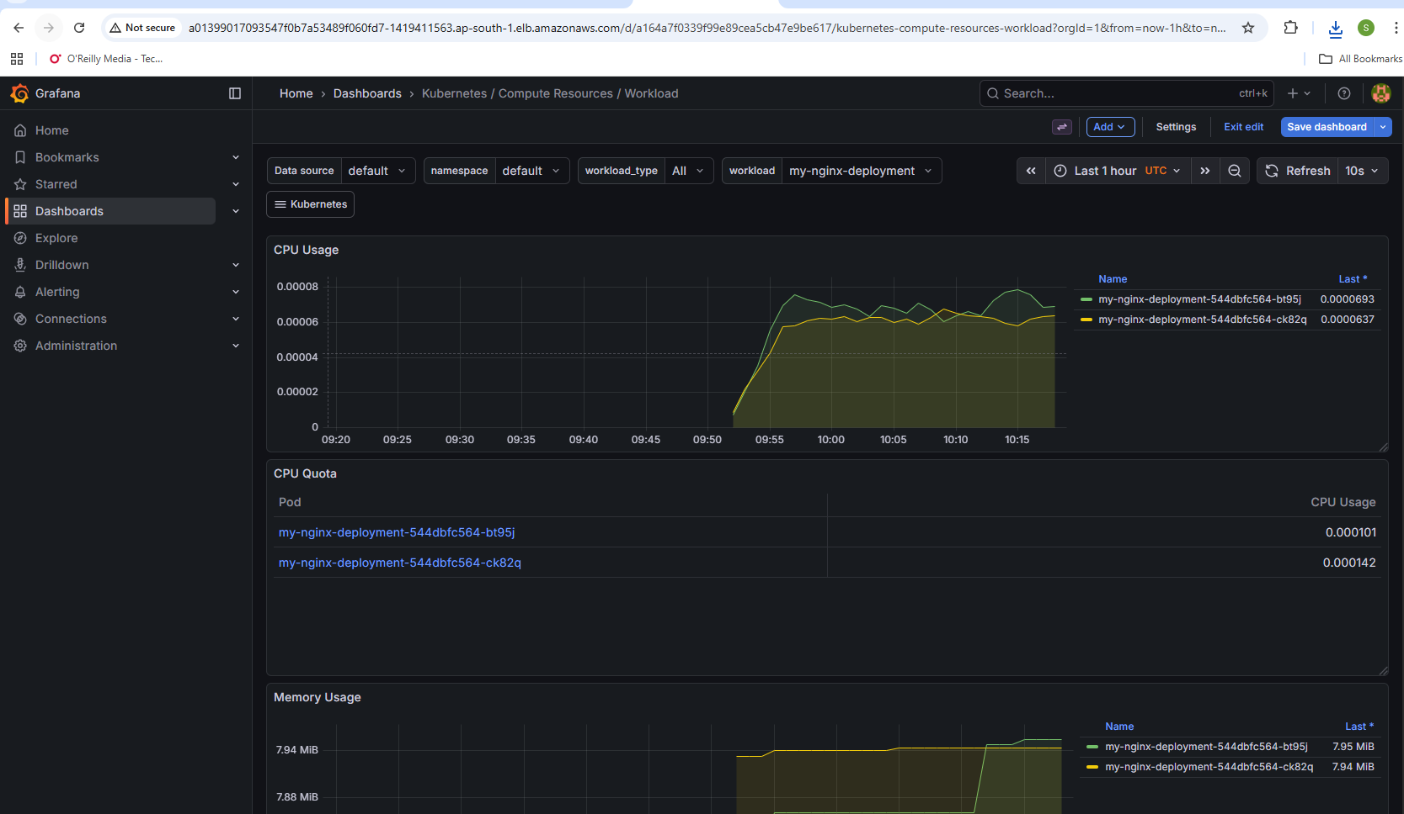
Node metrics
